Algebra 1 Unit 1 Study Guide

**Write each phrase as an algebraic expression.**

1. 12 more than a number 2. The quotient of a number and 9

3. 4 times a number cubed decreased by 7 4. 15 less than a number squared

5. 4 times the number of cows plus 2 times the number of ducks

**Write a verbal expression for each algebraic expression.**

6. 7. 6 – 4y

8. 4d3 - 10

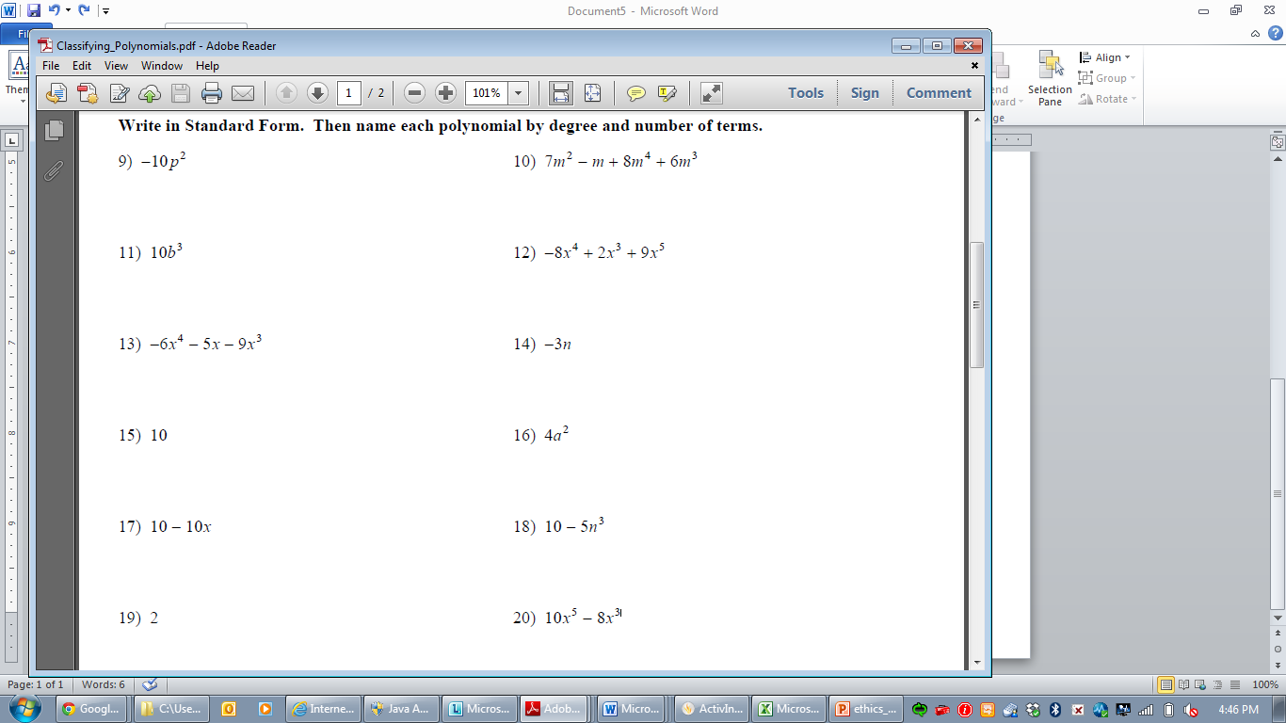

Operations with Polynomials

Simplify the following expressions.

|  |  |
| --- | --- |
| Complete the odds | Complete the evens |

Complete numbers divisible by 3.

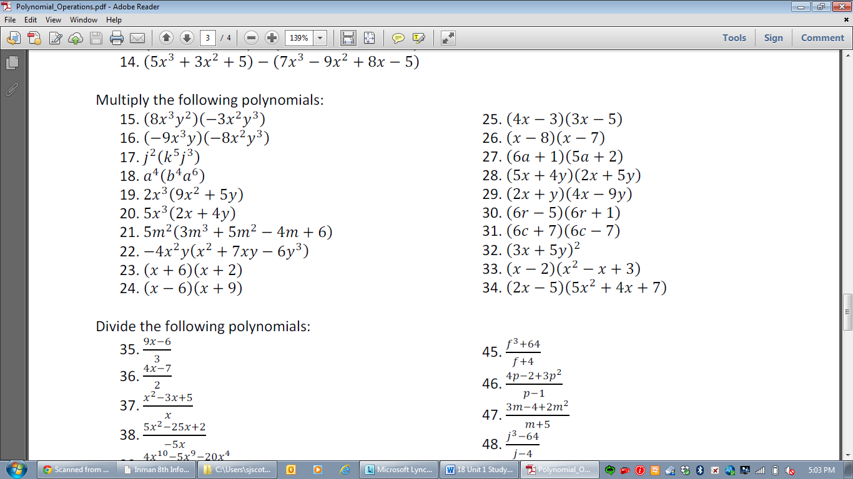

For the Algebra Tiles, draw the area as the size of each term.

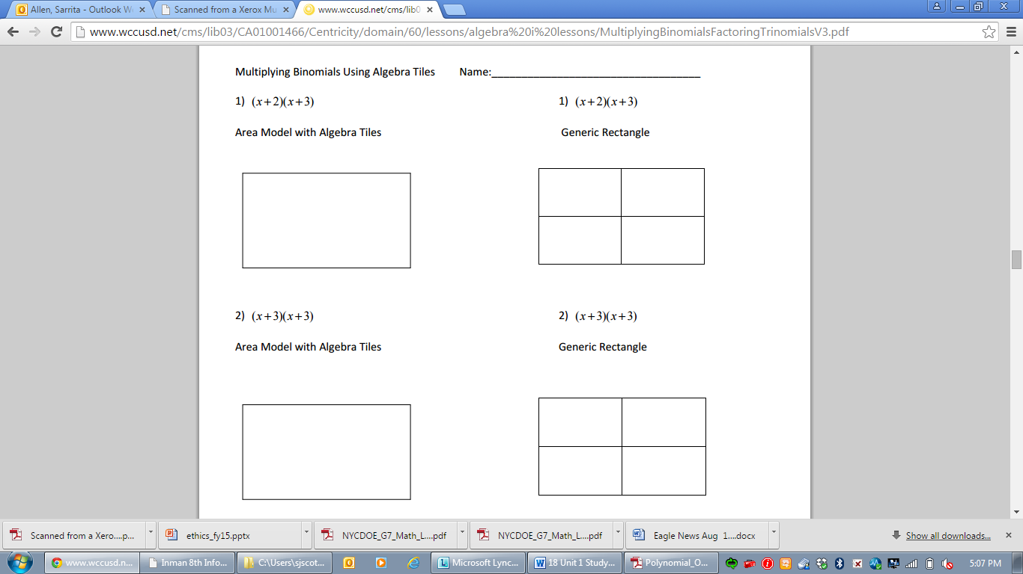

Simplify

   2

 6  

**Use dimensional analysis to convert each rate. Show all of your work and draw a line through the units that cancel.** Round your answer to the nearest hundredth.

1. Convert 25 feet per second to miles per hour. 2. Convert 75 miles per hour to feet per second.

3. The winner of the “Biggest Loser” lost .952 ounce per hour. Convert this to pounds per week.

4. Alex Rodriguez’s new contract is expected to be $30,000,000 per year. Convert this to dollars per minute.

5. It costs $.001 per hour for electricity to run a light bulb. Find the cost per month.

**Domain and Range/ Constraints**

For each problem: **a)** State the domain **b)** State the range **c)** Determine if the graph is a function

4) Tara’s car travels about 25 miles on one gallon of gas. She has between 10 and 12 gallons of gas in the tank.

a) List the independent and dependent quantities.

b) Find the reasonable domain and range values.

c) Write the reasonable domain and range as inequalities.

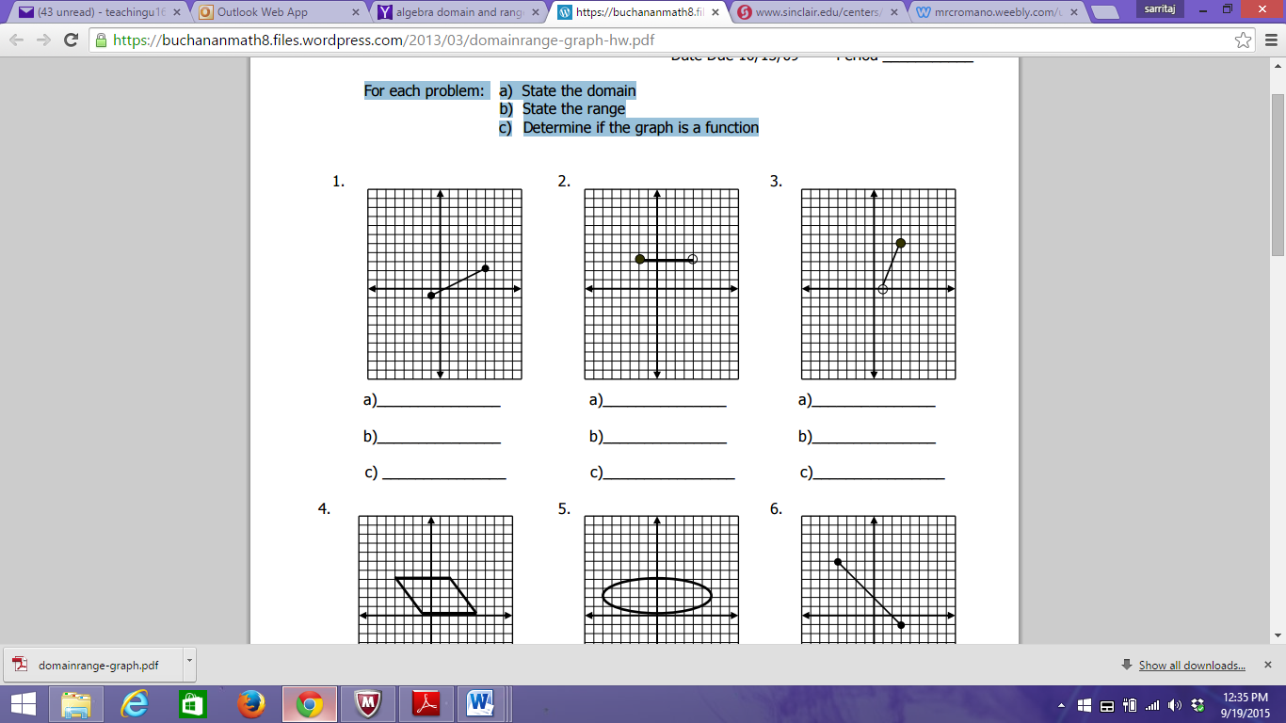 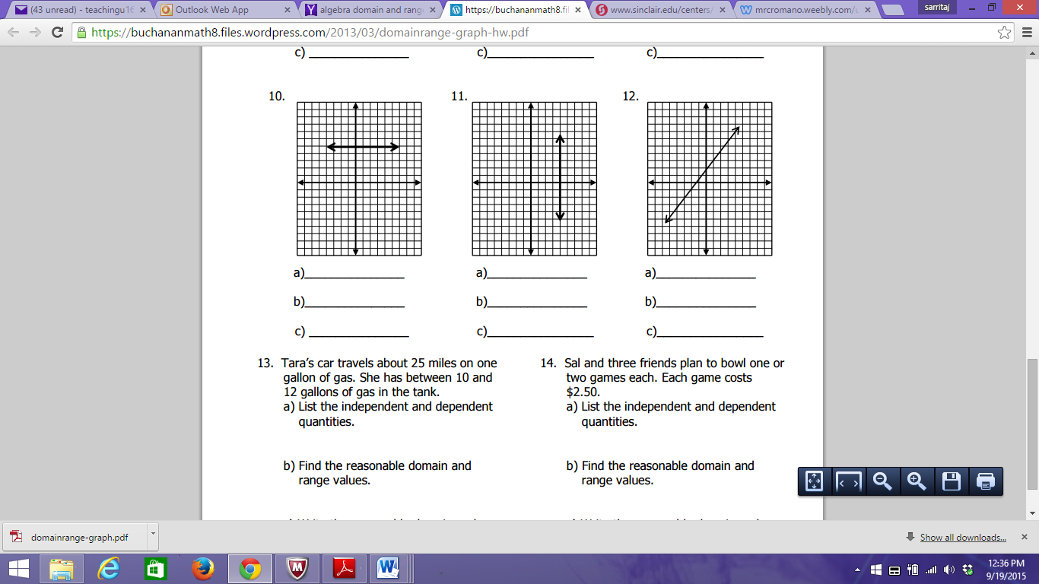

**Solve each of the following for the indicated variable.**

1. V = r2h for r

2. A = 1/2h(b + c) for c

3. x = (2y – z)/4 for y

4. for n

5. PV = nRT for R

6. 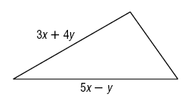The measures of two sides of a triangle are given. If *P* is the perimeter, and , find the measure of the third side.

7. The polynomial  models the profit a company makes on selling an item at a price *s*. A second item sold at the same price brings in a profit of . Write a polynomial that expresses the total profit from the sale of both items.

8. **Find the area of the rectangle pictured:**

**2x2 + 6x - 3**

**7x**

**9. Michelle borrowed 3r3 + 5r2 + 18r + 20 dollars from her brother. If she paid back 3r3 + 2r2 – 2r + 11 dollars, then how much more money does she still owe her brother?**

**10. What is the degree of the polynomial: 3a3b4 – 6ab4 + 9a3b + 5b6**