1. a. What is the charge of an object that gains an electron?

b. What is the charge of an object that loses an electron?

2. Define **static electricity** –

3. Define and give an example of the three methods of static charging:

a) charging by friction:

example:

b) charging by conduction:

example:

c) charging by induction:

example:

4. What is an electrical conductor? Define and give 3 examples.

5. What is an electrical insulator? Define and give 3 examples.

6. What is current, and what is the unit of measurement for current?

7. What is voltage, and what is the unit of measurement for voltage?

8. What is resistance, and what is the unit of measurement for resistance?

9. What does Ohm’s Law state (mathematically?)

10. A circuit with a current of 20 amps has a resistance of 5 Ω. What is the voltage of the circuit?

11. Which of the wires below would have the highest resistance? Why?

**B**

**A**

12. Which of the wires below would have the highest resistance? Why?

**A**

**B**

13. Name the 3 essential parts of any electrical circuit.

14. What is a switch in an electrical circuit? How can a switch affect the current flowing through a wire in a circuit?

15. Draw a series circuit with 1 battery and 3 loads (lightbulbs).

* 1. How many paths do charges have to flow through in a series circuit? _____________
  2. If one of the bulbs burned out, what would happen to the other bulbs?
  3. If you added another bulb to the circuit, what would happen to the brightness of the other bulbs?

16. Draw a parallel circuit with 1 battery and 3 loads (lightbulbs).

* 1. How many paths do charges have to flow through in a series circuit? _____________
  2. If one of the bulbs burned out, what would happen to the other bulbs?
  3. If you added another bulb to the circuit, what would happen to the brightness of each bulb?

17. A circuit contains four light bulbs. One light bulb goes out but the other three stay lit. This must be a(n) ____________________ circuit.

a) open b) series c) parallel d) resistant

18. What is a **magnet**? Give the definition.

19. Where is the magnetic field the strongest on a magnet?

­­­­­­­­­­

20. a. Are the magnets below attracting or repelling each other? How can you tell?

b. What would happen if the magnet on the left were turned around, so that its north pole faced the north pole of the other magnet?



21. What is magnetic domain?

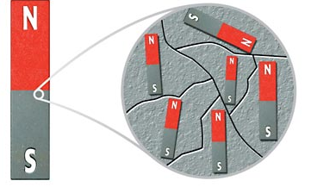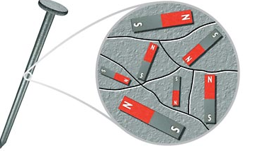22. Describe the magnetic domains in the two objects below. Which is magnetic? Which is not? How can you tell?

23. Name 2 ways to demagnetize a magnet.

24. What happens when you cut a magnet in half?

25. What is **electromagnetism**? Define.

26. Define **solenoid** –

27. What is an **electromagnet**? Give the definition.

28. What are 4 ways to increase the strength of an electromagnet?

29. Describe the energy transformation that takes place with

a) a battery: energy to energy

b) a generator: energy to energy

c) a motor: energy to energy

30. Use the diagrams below to answer

the questions that follow.

a. What kind of magnets are shown?

b. Assuming the batteries are the same, which magnet

do you think would be stronger, A or B? Explain your

answer.

c. List at least two factors that can be varied to change the strength of the magnets shown above.