Physical Science Year Long Study Guide – 2014-2015
Standards S8P1a. Distinguish between atoms and molecules
S8P1b. Describe the differences between pure substances and mixtures
S8P1d. Distinguish between physical (density, melting point, boiling point) and chemical (reactivity, combustibility) properties of matter
- Which of the following refers to a physical property of a substance?
  - Carbon combines with oxygen to form Carbon Dioxide
  - Acids are corrosive
  - The density of copper is 8.93 g/cm³
  - Zinc reacts with an acid to produce Hydrogen gas.
- Sodium hydroxide is formed with Sodium, Oxygen and Hydrogen join together chemically. How is sodium hydroxide classified?
  - Compound
  - Element
  - Mixture
  - Solution
- A group of identical atoms would be classified as
  - A solution
  - A compound
  - A mixture
  - An element
- Which of the following is a mixture?
  - Ocean water
  - Liquid Nitrogen (N)
  - Pure gold
  - Table salt (NaCl)
- Which of the following is an element?
  - NaCl
  - Fe₃O₂
  - OH
  - Fe

- Identify the following as a pure substance or a mixture.
If a pure substance, state whether it’s an element or a compound. If it’s a mixture, identify it as a heterogeneous or homogeneous mixture
soil Chicken Noodle Soup Carbon Dioxide(CO₂) Apple juice Nitrogen (N)
- (1 point) What is the difference between a heterogeneous and a homogenous mixture?

- Identify (3 points) the following as a physical (P) or chemical (C) property. Explain (3 points) your answers.
  - __The flammability of a substance
  - __The boiling point of water
  - __The electrical resistance of a metal
  - __The combustibility of wood

  - (3 pts) Calculate the density of the following objects
 | Object A | Object B | Object C
Mass | 34 g | 36 g | 12 g
Volume | 34 mL | 12 cm³ | 16 mL
- Is density a physical or chemical property?
- (3 points) Will each object float, sink, or be suspended in water(density = 1.0 g/mL)? Provide an explanation for your answers. (If you did NOT calculate part a., explain how you would know if an object will float or sink in water based on its density for 2 points).
Standard S8P1b. Describe the difference between pure substances (elements and compounds) and mixtures.
- Label each below as an element, compound, heterogeneous, or homogeneous mixture. (1/2 point each)
Write whether or not it is a pure substance. (1/2 point each)
  - Air
  - A solid gold (Au) ring
  - Fresh squeezed lemonade
  - Water (H₂O)
  - Helium (He)
- In your own words, what is the difference between a compound and a mixture? Use the phrases can be separated into parts by physical means, cannot be separated into parts by physical means, and chemically bonded in your answer. Also, include an example of each. (3 points)

- Laughing gas is used by dentists to put patients to sleep for surgery. The chemical name for laughing gas is Nitrous oxide (N₂O), it is formed when Nitrogen (N) and Oxygen (O) are chemically combined. Based on this information, how would you classify Nitrous oxide (element, compound, or mixture)?(1 point)
- Why did you decide to classify Nitrous oxide this way?(1 point)
- Gerald wants to separate Gatorade mix from water after it is all mixed together. What mixture separation technique would work best for this task? (filtration, magnetism, evaporation, distillation)
- Why did you choose this separation technique instead of the other three?
Standard S8P1c. Describe the movement of particles in solids, liquids, gases, and plasmas state.
- Compare and describe the motion (in terms of speed and separation) of particles in solids, liquids and gases (3 points)

- Fill in the state of matter that correctly matches the description. (1 point each)

__________________ Molecules are close together, but can slide past each other.
__________________ Molecules are locked in place and vibrate.
___________________Molecules have so much energy electrons escape from the molecules during collisions, making them ionized.
__________________ Molecules spread rapidly and collide often.
- Identify the phase change being described. (1 point each) (melting, freezing, vaporization, condensation,
________________ The exothermic change from a gas to a liquid.
________________ The endothermic change from a liquid to a gas.
________________ The exothermic change from a liquid to a solid.
- What is the difference between an endothermic and an exothermic change? (2 points)

- Draw the particles of a solid, liquid and gas. *Be sure to indicate whether or not they are moving and be clear about the distance between molecules. (3 points)

The following questions refer to the phase change diagram below
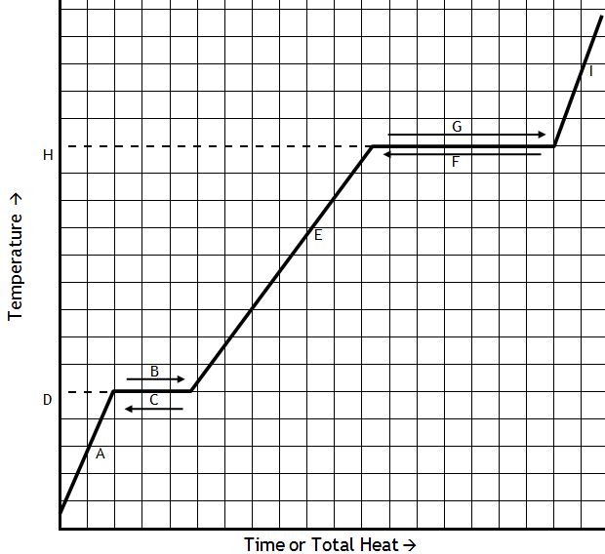
- The melting point of silver (Ag) is 962 ºC. Label this on your graph. (1 point)
- The boiling point of silver (Ag) is 2212 ºC. Label this on your graph. (1 point)
- If the temperature of a sample of Silver is below 962 ºC, what will be the state of matter of the sample? (1 point)

- During which portion (write the letter) of the graph is silver freezing? What happens to the temperature of Silver during the process of freezing? (2 points)
- What state of matter does silver exist as above its boiling point of 2212 ºC? (1 point)

- Hint: You don’t necessarily need DIAGRAM. If the temperature of silver is increased from 1000 ºC to 2000 ºC, what will happen to the motion of the molecules (discuss speed and distance between molecules). (2 points)

Standard: SP81g. Students will identify and demonstrate the Law of Conservation of Mass
- State the Law of Conservation of Mass in your own words (2 points):
- If the mass of the reactants in a chemical reaction is 158.6 grams, what is the mass of the products (1 point)?
- The reactants involved in a chemical reaction are shown. How many O atoms must be present in the product that forms from this reaction (1 point)?
CO₂ + H₂O → ?
- Which of these always stays the same during a chemical reaction (1 point)?
  - the temperature
  - the arrangement of the atoms
  - the color
  - the number of atoms
- Label the products and reactants in the equation below (1 point). What mass of Chlorine gas is required for this reaction to occur (1 point)?
2KI + Cl₂ → 2KCl + I₂
13g + ___→ 17g + 10 g
- An Alka-Seltzer tablet weighing 3 grams is added to an open flask of water (weighing 250 grams). At the end of the experiment, the flask weighs a total of 249.6 grams. Explain why this experiment does not seem to follow the Law of Conservation of Mass and how the experiment could be changed to show the Law of Conservation of Mass. (HINT: Your answer should talk about open and closed systems) (2 points)
HINT: Chemical reaction for Alka-Seltzer is:
NaHCO₃ + Citric acid ---> CO₂ + H₂O + Sodium Citrate
- True or false: The mass of the gas and ash produced after a log burns will have the same mass as the original log. Explain. (1 point)
- Identify the following equation as either balanced or unbalanced. If it is unbalanced, add coefficients to balance them (2 points each).
  - Balanced/Unbalanced: __NaCl ➔ __Na + ___Cl₂
  - Balanced/Unbalanced: ___Fe + ___O₂ → ___Fe₂O₃
  - Balanced/Unbalanced: ___H₂ + __ Cl₂ → ___ HCl
Standard: S8P1f. Recognize that there are more than 100 elements and some have similar properties as shown on the Periodic Table of Elements.
Use the periodic table square to the right to answer the following questions (1 point each):  1. ______________What is the element’s name?  2. ______________What is the element’s chemical symbol?  3. ______________What is the element’s atomic number?  4. ______________What is the element’s atomic mass?  5. _____________How many neutrons does the element have?  Show your work: | 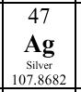

6. What do elements in the same group have in common? Use complete sentences. (1 point)
7. What do elements in the same period have in common? Use complete sentences. (1 point)
8. As you go down a group, the number of electron energy levels of the elements (increases/decreases/does not change). (1 point)
9. Draw a picture and explain the difference between a valence electron and an electron energy level. Include the terms valence electron and electron energy level in your diagram/explanation. (3 points)

10. You discover a new element, but now you need to place it on the periodic table! It is shiny, soft and extremely reactive. It reacts with elements in group 17 to form a white substance that looks like table salt. What would you classify the new element as (specific name of the group), and where would you put it on the periodic table? Explain your answer. (3 point)

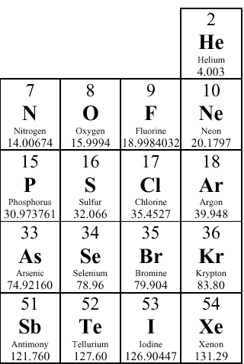 | 11. Look at the part of the periodic table pictured at left. What is another element that has similar properties to Chlorine?(1 point)  12. How do you know the element you listed in question 40 had similar characteristics to Fluorine? (1 point)  13. Which group of elements shown on the table are the least reactive? (1 point) What is this group called? (1 point)

Standard: S8P2a. Students will explain energy transformation in terms of the Law of Conservation of Energy
- State the Law of Conservation of Energy in your own words (2 points):

- If a candy bar has 200 calories of energy, how much of this energy will be lost when it is digested by a person (1 point)?

The following questions are 1 point each. Identify the type of energy. You can use an answer more than once.
Electrical Radiation Sound Thermal Motion/Mechanical Chemical Elastic P.E. Nuclear Gravitational
- The fluorescent lights in this room allow you to read you papers. What type of energy provided by the lights helps you read?
- When the strings of a guitar are plucked they vibrate. These vibrations are transferred to particles in the air. What kind of energy is produced by these vibrating particles?
- When moving air strikes the blades of a windmill, it causes the blades to turn. What kind of energy is involved in the movement of the blades?
- What kind of energy does a computer need to turn on?
- A hiker on the top of Mount Everest has more _________________ energy than someone at the bottom of the mountain.
- What kind of energy allows water to boil on a stovetop?
- An uneaten apple has this type of energy.
- What type of energy does a moving bicycle have?
- What is the difference between chemical and nuclear energy (2 points)
For the following questions identify the energy transformation taking place using the format:
input energy →output energy (2 points each)
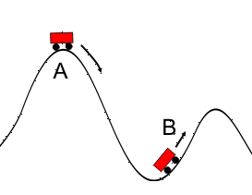
- A roller coaster travels from A to B

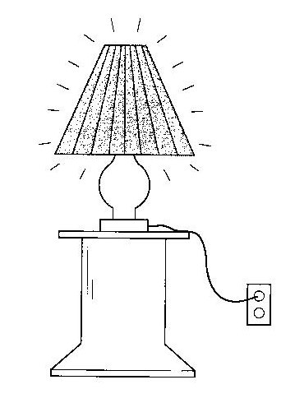
- A lamp is plugged in then turned on.

- A runner eats pasta then runs a marathon.

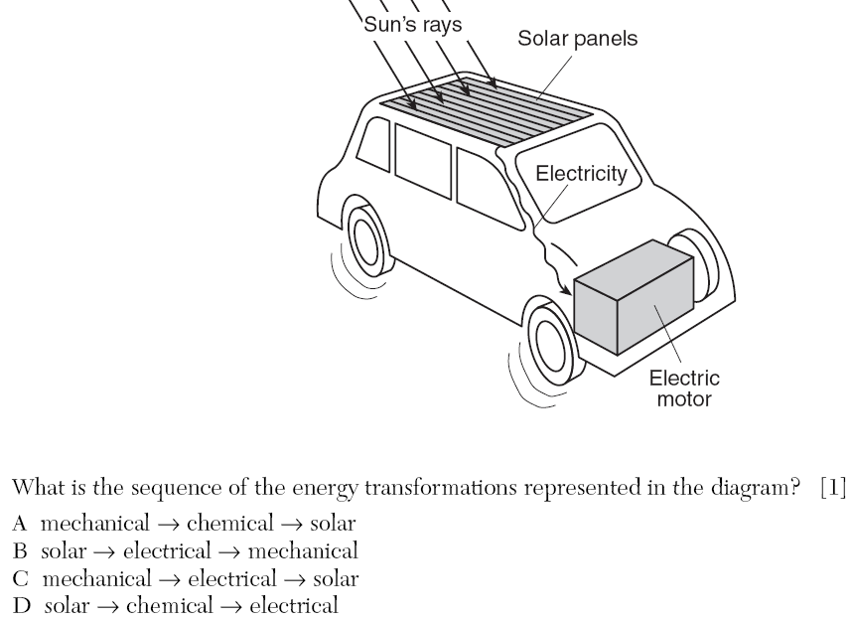

Standard: S8P2b. Explain the relationship between potential and kinetic energy.
SHOW YOUR WORK Helpful equations: Kinetic Energy = ½ * m * v² Potential Energy = m * g * h
- Use the diagram below for questions 1-5
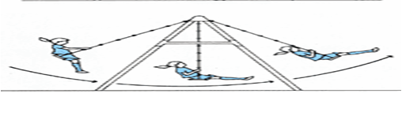

- Label the point(s) on the swing with the most potential energy with a P. (1-2 points).
- Label the point(s) on the swing with the most kinetic energy with a K. (1-2 points).
- How does the total energy of the swing change throughout its path in the picture? (2 points)
- If the girl has a mass of 50 kg and is at a height of .5 meters off the ground in the left side of the picture, how much potential energy does she have? (g = 10 m/s²). (1 points)
- (NEW GIRL!) If the girl has a mass of 30 kg and is moving at a rate of 2 m/s at the bottom of the swing, calculate her kinetic energy (1 points).
Use the diagram below for the following questions
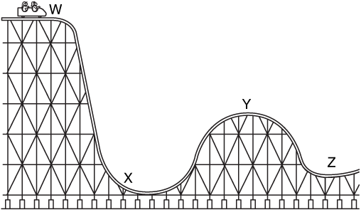
- Which point on the roller coaster has the most potential energy? Why? (1 point)
- Which point on the roller coaster has the most kinetic energy? Why? (1 point)
- Describe the energy transformation that takes place from X → Y. (2 point)
- The height of point W is 50 meters. If the cart has a mass of 100 kg, what is the potential energy (g =10 m/s²)? *This is the total energy of the coaster. (1 point)
- If the height of point Y is 10 meters, how much potential energy does the coaster have at that point? (mass = 100 kg, g = 10 m/s²) How much kinetic energy does the coaster have at that point? (2 points)
Standard: S8P3d. Describe how heat can be transferred through matter by the collisions of atoms (conduction) or through space (radiation). In a liquid or gas, currents will facilitate the transfer of heat (convection).
- What is conduction? Give an example of conduction. (2 pts.)

- What is convection? Give an example of convection. (2 pts.)

- What is radiation? Give an example of radiation. (2 pts.)
- Is this diagram correct or incorrect? Explain you answer. (2 pts.)
40°C
25°C

Heat transfer

- To celebrate the 4th of July holiday, Lisa decided to barbeque chicken for dinner over a fire. Describe how the chicken will cook through conduction, convections, and radiation. (3 pts.) ____________________________________________________________________________________________________________________________________________________________________________________________________________________________________________________________________________________________________________
Identify the following heat transfer as (1) conduction, (2) convection, or (3) radiation (1 pt. each.)
- You feel the warm glow of a bonfire.
- A burner on a stove heats the bottom of a pot.
- Within a pot of water.
- Occurs when atoms collide.
- When hot air rises.
S8P4a. Identify the characteristics of electromagnetic waves.
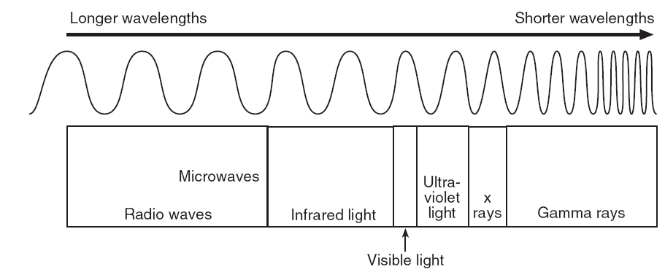
- Which type of electromagnetic wave has the most energy? Explain. (2 points)

- Which type of electromagnetic wave has the highest frequency? Explain. (2 points)

- Which type of electromagnetic wave has the longest wavelength? Explain. (2 points)

- What are two differences between electromagnetic and sound waves? (2 points)

- Do electromagnetic waves need a medium? Explain/use an example. (2 point)

- How do frequency and energy relate in electromagnetic waves? (2 points)

S8P4b. Describe how the behavior of light waves is manipulated causing reflection, refraction, diffraction, and absorption.
- When visible light hits a mirror, the light is ______ __________ off of the mirror.
- Light bends through a convex lens creating a larger image to someone looking through the lens, this property of light bending when it passes from one medium to another is called ______ __________.
- White light passes through a narrow opening and bends, separating the wavelengths of the visible light spectrum. This property of light is called ________ _____________________.
- When visible light hits a ______ ________________ object like a window, all the light is transmitted through the window.
- When light hits black pavement on the road, the light is all _______________ by the pavement.
- When light hits a _____ ________________ material, light passes through it but the light is scattered, making the object appear blurry to an observer on the other side.
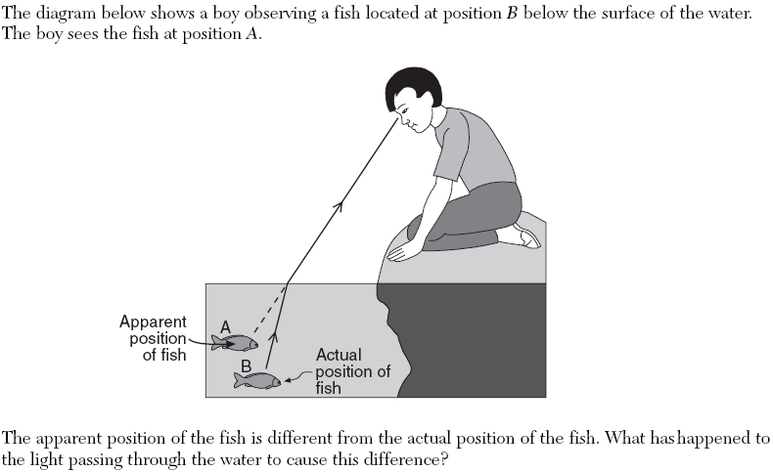

- Explain why a Boston Celtics jersey appears green in terms of wavelengths, reflection, and absorption.

S8P4a. Identify the characteristics of electromagnetic and mechanical waves.
- What do waves transfer (1 point)?
  - Matter
  - Energy
  - Water
  - Air
- The material (matter) that waves travel through is called the _______________ (1 point).
- (4 points) Using the pictures below, which wave has the greater frequency? (1 point) Which wave has the greater wavelength (1 point)? Show how you would measure wavelength for both of the waves (1 point). Show how you would measure amplitude for one wave (1 point).
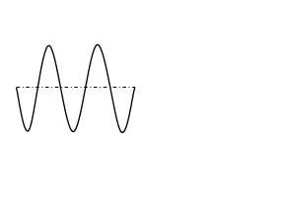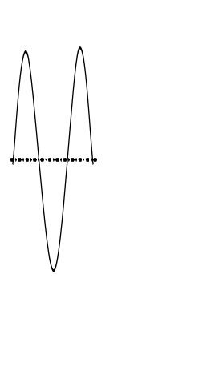

- Which type of wave requires a medium, an electromagnetic or a mechanical wave?
- Describe the relationship between wavelength and frequency (at constant speed) (2 points). Draw a picture if it helps your explanation.
- Describe the relationship between amplitude and the energy carried in a mechanical wave (2 points).

S8P4d. Describe how the behavior of waves if affected by medium
S8P4e. Relate the properties of sound to everyday experiences.
- Rank the order of the speed of sound through the following materials from fastest to slowest.
(Warm air, water, concrete, cold air) (2 points)
- Explain your answer to number 1 (2 points).

- The two following diagrams are representations of sound waves (although sound waves are longitudinal, it is easier to represent them as transverse waves).
- Which wave would produce a louder sound? Why? (2 points)
- Which wave would produce a higher pitched sound? Why? (2 points)
- Which wave will carry more energy? Why? (2 points)

- The picture below represents a train moving to the right.
- Label a point on the below diagram where an observer would hear a lower pitched sound (1 point).
- Explain why the person would hear a lower pitched sound at this point (2 points). (include the name of this physical situation in your description for full credit)

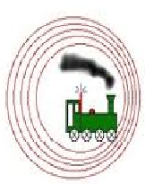
S8P5b. Demonstrate the advantages and disadvantages of series and parallel circuits
- Describe three advantages of wiring a house in a parallel circuit as opposed to a series circuit. (6 points).

- A. In the pictures below, draw an arrow indicating the direction(s) electrons will flow through the circuits (1 point).
B. Circle the circuit in which the failure of one light bulb will not affect the other bulbs (1 point).
C. Explain your answer for part B (1 point).
D. If the switch is open in the circuit on the left, what will happen? Why?
E. If the switch was made of plastic instead of metal, would the circuit still work? Why?

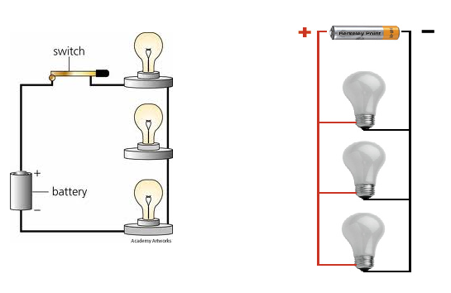

S8P5a. Gravity
- How does the mass of two objects affect the amount of gravitational force between them?

- How does the distance between two objects affect the amount of gravitational force between them?

S8P5c. Investigate and explain that electric currents and magnets can exert force on each other.

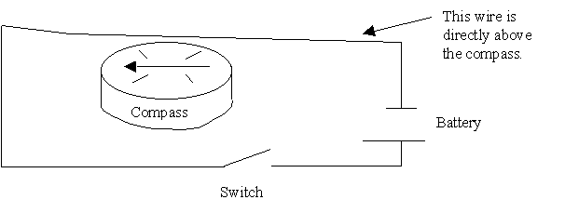
- A. Using the circuit diagram above, describe what will happen to the compass when the switch is closed? (1 point)

B. What will happen to the compass if the battery is flipped around? Will it be different from 4A? (1 point)

C. Describe what happens in the wire that causes 4A and 4B to occur. (2 points)
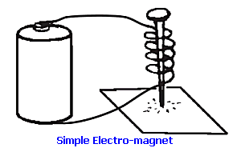

- A. If there are iron filings on the paper in the picture above, what will happen to when the wires are touched to both ends of the battery? (1 point)

B. Why does this happen in A? (1 point)

C. Describe two ways you can increase the strength of the electromagnet in the picture above (2 points)

