1. Fill in the two way table below based on the information given.

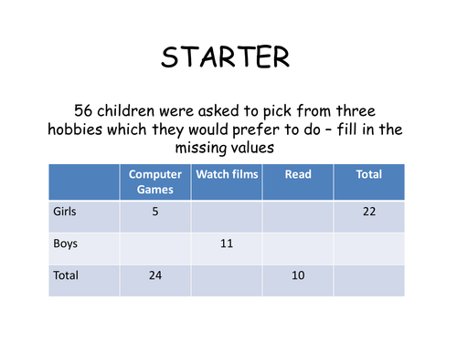

Fill in the Table

Part A: Of the number of children who were surveyed, how many prefer films? Write your answer as quantity, a fraction and a percent.

2. A certain cell phone company charges $75 a month for their calling and texting plus an additional $0.15 per hour for data usage. If “x” represents the total number of hours of data used during any given month and “y” represents the cost of the bill for that month, find the following:

Part A: What is the slope of the line and what does it represent?

Part B: If no data was used during a particular month, how much is the bill?

Part C: Find the equation of the line.

Part D: Find the cost of a bill during a month where 25 hours of data were used.

3. The scatter plot shows the relationship between the age of a reader and the time, in hours, the reader spends each month. 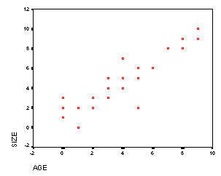
Hours Reading

Part A: Draw a line of best fit (using a ruler). What type of association is shown between the age of the reader and hours spent reading per month?

Part B: Write an equation (in slope intercept form) that would best represent the data shown in the scatter plot. Describe what the slope and y-intercept represent in the context of this situation.

