1. An __________________ is the building block of matter.

a. The _________________ contains most of the mass of the atom.

b. The _________________ contains most of the volume of that atom.

2. **Complete the table below:**

|  |  |  |
| --- | --- | --- |
| **Subatomic particle** | **Location in atom** | **Charge** |
| **Proton** |  |  |
| **Neutron** |  |  |
| **Electron** |  |  |

3. Atoms have no charge because the number of __________________ and _______________ are equal.

4. Use the element card below to answer the questions to the right.

**11**

**Na**

**Sodium**

**22.98**

a. How many protons does sodium have? _________

b. How many electrons? _________

c.The atomic number of sodium is _________

**A**

a. A is a ______________________.

b. B is a ______________________.

c. Elements in the same _____________ have similar properties.

**A**

**B**

5.

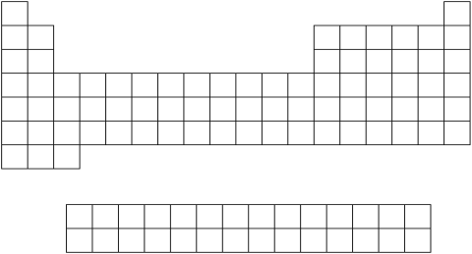

**B**

6. Use the periodic table to determine if each of the following elements is a metal, nonmetal, or metalloid.

|  |  |
| --- | --- |
| a. Ca ____________________________ | d. Co __________________________ |
| b. Si _____________________________ | e. Br __________________________ |
| c. Ne ____________________________ | f. B ___________________________ |

7. For each element listed below, list another element on the Periodic Table that would have similar properties.

a. Lithium __________ b. Phosphorus _______________

c. Neon ____________ d. Magnesium _______________

8. The most reactive metals are the ________________ metals in group .

9. The metals in groups 3-12 are called metals.

10. The most reactive nonmetals are the in group .

11. The nonreactive elements are the and are in group .

12. How many atoms are in each of the following molecules?

a. NaHCO3 b. Fe2O3 c. C9H8O4

13. How many grams of H must have been formed in the chemical reaction below?

2Zn + 2HBr  2ZnBr + H

15g 5g 12g ___g

14. Choose the balanced equation from the choices below.

a. 2MgF + LiCO  2MgCO + 2LiF b. MgF + LiCO  MgCO + 2LiF

c. MgF + 3LiCO  3MgCO + 2LiF d. 2MgF + 2LiCO  MgCO + 4LiF

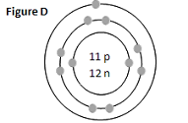

15. The graphic to the right represents an atom of the element .

16. Label the following pictures as representing a solid, liquid, or gas.

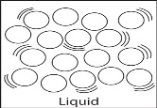

c.

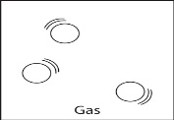

b.

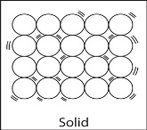

a.

17. Fill in the blanks in the table below with the words **definite** and **indefinite**.

|  |  |  |
| --- | --- | --- |
|  | **Shape** | **Volume** |
| **Solid** |  |  |
| **Liquid** |  |  |
| **Gas** |  |  |



a. At what temperature does the substance melt?

b. At what temperature does the substance boil?

c. What state of matter would the substance be in at 10°C?

d. What state of matter would the substance be in at 40°C?

18.

19. Complete the following chart.

|  |  |  |
| --- | --- | --- |
| **Phase Change** |  | **Endothermic or Exothermic?** |
|  | Solid 🡪 Liquid |  |
|  | Liquid 🡪 Solid |  |
|  | Liquid 🡪 Gas |  |
|  | Gas 🡪 Liquid |  |
|  | Solid 🡪 Gas |  |
|  | Gas 🡪 Solid |  |

20. Identify the following as being physical (P) or chemical (C) properties.

a. density c. combustibility e. reactivity

b. melting point d. color f. shape

21. When two or more elements combine to make a compound, the compound:

a. has the same properties as the elements that make it up

b. is a new substance with new properties

22. When two or more substances combine to make a mixture, the substances:

a. keep their original properties b. change into new substances with new properties

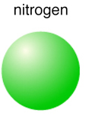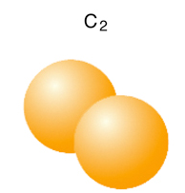23. Which of the following are molecules?

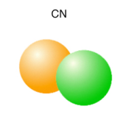

a. b. c.

d. both A and B e. none of the above

24. Fill in the blanks in the graphic organizer below.

Heterogeneous

Matter

Pure Substance

**25. Label the following substances as being:**

A. Element B. Compound C. Heterogeneous mixture D. Homogeneous mixture

|  |  |  |
| --- | --- | --- |
| _____1. Gold (Au) | _____5. Salt water | _____9. Water (H2O) |
| _____2. Sugar (C12H22O11) | _____6. Salt (NaCl) | _____10. Silver (Ag) |
| _____3. Air | _____7. Salad | _____11. Fluorine (F) |
| _____4. Pizza | _____8. Limestone (CaCO3) | _____12. Steel |

26. For each of the statements below determine if it describes an element (E), compound (C), or mixture (M).

|  |  |
| --- | --- |
| ____2 elements chemically joined together  ____substances physically combined  ____pure substance that consists of only 1 type of atom  ____substances lost their properties when combined | ____can be separated by physical means  ____cannot be separated by physical means  ____all have a molecular/chemical formula |

27. Label the following as:

a) pure substance (element) b) pure substance (compound)

c) mixture of elements d) mixture of compounds

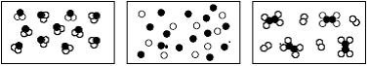

__________ _________ ___________

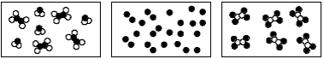

__________ _________ _________

28. What are some clues that a chemical change has occurred?

**29. Use the chart below to answer the next 2 questions**.

a. If iron pyrite were dropped into a beaker of mercury, would it sink or float? Explain your answer.

b. If iron pyrite were dropped into a beaker of water, would it sink or float? Explain your answer

|  |  |  |  |
| --- | --- | --- | --- |
| **Substance** | **State** | **Density (g/cm3)** | **Color** |
| Helium | gas | 0.0001663 | colorless |
| Iron pyrite | solid | 5.02 | metallic yellow |
| Mercury | liquid | 13.55 | metallic gray |
| Oxygen | gas | 0.001331 | colorless |
| Water | liquid | 1.00 | colorless |

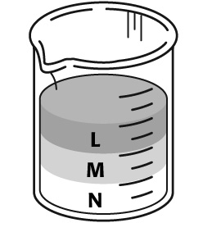

30. Which substance in the beaker to the right is the densest? The least dense?

31. A substance has a mass of 30 g and a volume of 5 mL. What is its density?

32. In every energy conversion, some energy is always converted to energy.

33. The table below contains definitions describing the different forms of energy. Determine what type of energy is being described, then complete the table.

|  |  |
| --- | --- |
| a. The energy of moving electrons |  |
| b. Travels in waves through vibrations and collisions of matter; mechanical wave |  |
| c. Travels as a wave and a particle (photon); electromagnetic wave |  |
| d. stored energy |  |
| e. the total kinetic energy of the particles in a substance |  |
| f. energy of motion |  |
| g. energy of an object’s motion and position; type of energy in moving water and wind |  |
| h. the energy stored in the bonds between atoms, like in food and fuels (coal, wood, etc.) |  |
| i. the energy stored in the nucleus of an atom |  |



34. At what point does the roller coaster have the most:

A. Potential energy? Why?

B. Kinetic energy? Why?

35. How are kinetic energy and speed related? How are kinetic energy and mass related?

36. How are potential energy and weight related? How are potential energy and height related?

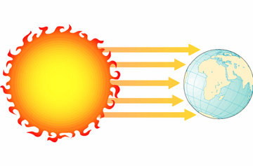37. Do the following pictures represent conduction, convection, or radiation?

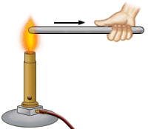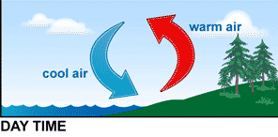

a. b. c.

38. What states of matter can transfer heat through convection?

39. Match the terms below with their definitions.

|  |  |
| --- | --- |
| ______1. Heat | a. the *total* kinetic energy of all the particles in a substance |
| ______2. Thermal energy | b. the *average* kinetic energy of the particles in a substance |
| ______3. Temperature | c. the transfer of energy between objects at different temperatures |

40. What would have more thermal energy, a giant iceberg or a cup of hot coffee? Explain.

41. Explain thermal expansion and contraction. What happens to the particles in matter when they expand? When they contract?

42. 14. Explain the energy conversions in each situation.

Examples: battery: chemical energy 🡪 electrical

[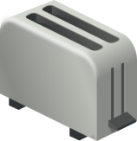](javascript:edit(25521)) a. toaster

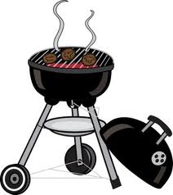

b. you burn coal on a grill

 c. light bulb

d. alarm clock

43. Use the two oscilloscope graphs of sound waves below to answer the questions that follow.

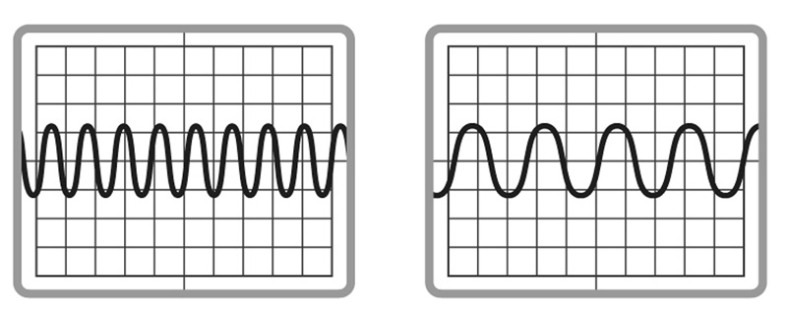

Wave A Wave B

a. Compare the amplitudes of the two waves. Would the volumes of the two sounds be different? Why or why not?

b. Which wave has the highest frequency?

c. Which wave represents the sound with the lowest pitch?

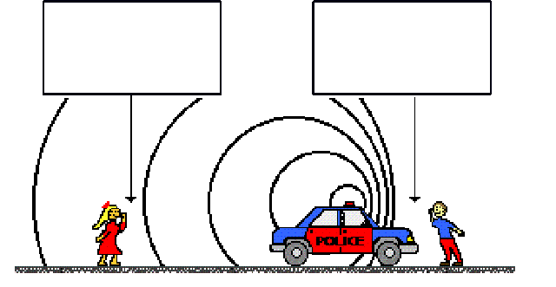44. Label which side of the police car has high frequency and which side has a low frequency. Then explain what the police siren sounds like to each listener.

45. a. Rank the order of the **speed of light** through the following materials from **slowest** to **fastest** air, water, a vacuum (like outer space), glass

Slowest Fastest

a. Rank the order of the **speed of sound** through the following materials from **slowest** to **fastest** cold air, warm air, water, glass

Slowest Fastest

46. a. Draw 2 lenses: one concave, and one convex. Which lens is converging? Which is diverging?

b. Draw 2 mirrors: one concave, and one convex. Which mirror is converging? Which is diverging?

47. Draw examples of reflection, refraction, and diffraction.

48.Explain absorption and reflection in terms of the colors that we see.