Study Guide: Motion, Forces, and Newton’s Laws
Part I: Motion
- Give 3 examples of units that can be used to measure speed.

- What is the formula used to calculate average speed?

- A train travels 560 kilometers in 7 hours. What is the average speed of the train? Show your work.

- Brandon walks 900 meters in 300 seconds. What is his average speed? Show your work.

- If a student rides her bicycle on a straight road and does not speed up or slow down, she is traveling with a
a. constant acceleration. b. constant velocity.
b. positive acceleration. d. negative acceleration.

- Explain the difference between speed and velocity.

7. What is acceleration?

8. A car drives in a circle at a constant speed. Is the car accelerating? Why or why not?

9. Which of the following is NOT an example of acceleration?
a. a person jogging at 3 m/s along a winding path c. a cheetah running 27 m/s east
b. a car stopping at a stop sign d. a plane taking off

10. What units are used to measure acceleration?

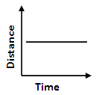
11. Describe the motion shown in each of the graphs below. (no motion, constant speed, or acceleration?)
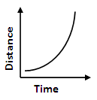
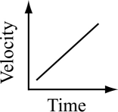
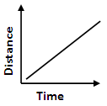
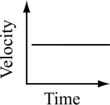
A. B. C. D. E.

12. Use the graph below to answer the questions.
a. What was Erin’s average speed?

b. What was John’s average speed?

c. Which person raced at a constant speed?

d. What was Sarah’s average speed for the first 5 minutes of the race?

a. During which sections was the object accelerating?

b. During which sections was the object decelerating?

c. During which sections was the object traveling at a constant speed?

B
C
D
E
F
G
13.

d. What is the formula used to calculate acceleration?

e. Calculate the acceleration of the object during section A.

Part II: Forces
14. Calculate the net force in each diagram. Predict the direction each object will move.
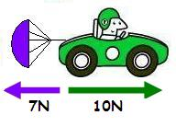
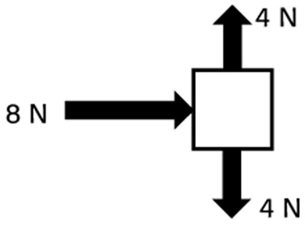
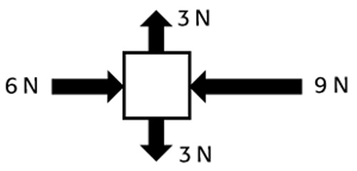
a. b. c.

d. In part c), what types of friction are acting on the car? What is a specific name for the force acting on the parachute?

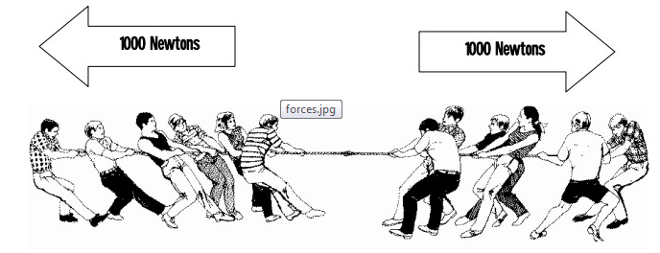
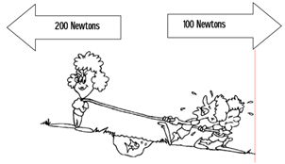
15. For each situation shown below, tell (A) if the forces are balanced or unbalanced, (B) what the net force is, and (C) which direction the rope will move, if any.

A. A.
B. B.
C. C.

16. What is the definition of force, and what unit do we use to measure force?

17. A) What is the net force when forces are balanced? B) What happens to an object’s motion when the forces acting on it are balanced?

18. Define friction.

19. Complete the table below by filling in the 4 types of friction, and giving an example of an object experiencing that type of friction.
Type of friction | Example

20. Define gravity. What 2 things determine the gravitational force between objects?

21. An astronaut leaves earth and goes to the moon, where the force of gravity is much lower.
a) Why is gravity is lower on the moon than on earth?

b) What would happen to the astronaut’s mass when he goes to the moon?

c) What would happen to the astronaut’s weight when he goes to the moon?

22. Use the picture below to answer the questions.
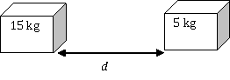
.

a) What would happen to the gravitational force between the two boxes if the distance, d, between them increased?

b) What would happen to the gravitational force between the two boxes if the mass of either object increased?

23. Ms. Starnes drops two bowling balls from the same height: one with a mass of 10 kilograms, and one with a mass of 100 kilograms. In the absence of air resistance, what will happen?

24. Is it possible to be completely weightless? Why or why not?

25. True or false: Your cell phone is too small to exert a force of gravity on the earth.

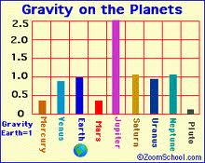
26. This graph shows the force of gravity on earth and other planets. If a mass of 5 kg was dropped from the same height on each of these planets, on which planet would:
A) the ball fall fastest?

B) the ball fall slowest?

C) the ball weigh the most?

D) the ball weight the least?

27. Explain the difference between mass and weight.

28. Write Newton’s First Law of Motion here:

29. Newton’s First Law is also called the law of Inertia. Define inertia:

30. What is the relationship between the mass of an object and its inertia?

31. Imagine a place in space, far from all frictional and other unbalanced forces. Suppose that an astronaut throws a rock. The rock will:
a) move quickly in a straight line but eventually slow down and stop.
b) move in a straight line at a constant speed, without ever stopping.
c) move slowly but gradually pick up speed.

Which of Newton’s Laws explains your answer to 31?

32. Your friend Jose says that Newton’s First Law must be incorrect, because when he rolls a ball down the hallway, it eventually stops, even though there are no outside forces acting on the ball! Is Jose’s reasoning correct? Why doesn’t the ball remain in motion?

33. State Newton’s 2nd Law of Motion and write the formula that explains Newton’s 2nd Law.

34. Complete the calculations:
a. What is the net force needed to accelerate a 50.0 kg bowling ball at 2.0 m/s²?

b. A skydiver with a mass of 80.0 kg is accelerating at 4.0 m/s². What is the force of the air resistance acting on the skydiver?

35. State Newton’s 3rd law of motion

36. Give an example of an action/reaction force pair.

37. The reaction force of a chair you are sitting on
  - is greater than your weight. c. is determined by many factors.
  - is equal to your weight. d. varies

Momentum
38. How do you calculate momentum?

39. Calculate the momentum of a 5.0 kg fish swimming at 40 m/s.

40. Calculate the momentum of a 2000 kg car travelling 14 m/s.

41. In the blanks before each statement, write the number (1, 2, or 3) of Newton’s Laws that is described.

a. A baseball pitcher uses a greater force to throw a ball faster.
b. Mass x Acceleration
c. You’re standing in a bus. You fall back when the bus starts to move.
d. For every action, there is a reaction.
e. You can walk because the floor puts a force on your foot as your foot puts a force on the floor.
f. When you push down on your desk, the desk does not collapse because it puts an upward force on your hand.
g. To move at the same acceleration, a heavier mass needs more force than a small mass.
h. You roll a ball down the hallway, but it slows down and eventually comes to a stop.

42. Calculate the force on each of the 4 balls. Which pair is colliding with equal force?
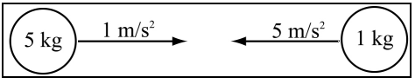
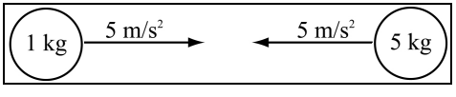

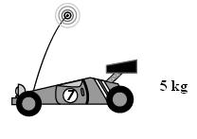
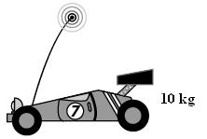
43. The cars below are racing toward a wall, each with an acceleration of 10 m/s². Which car will hit the wall with the greatest force? Why?

A B C
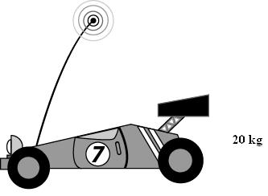

44. Olaf is sliding down hill on is belly to save Anna from Cristof. Draw a free body diagram of Olaf as he is headed down hill with an ever increasing speed.

45. A worm on a hook is hanging motionless ( there’s a sea bass nearby). Draw a free body diagram of the worm.

