**Study Guide: Structure and Chemistry of Matter** Name Date

1. Define matter.

2. What is the difference between mass and weight?

3. What is the difference between an element, an atom, and a molecule?

4. Draw an example of each.

5. There are 3 subatomic particles in the atom. Fill in the blanks in the following chart, including the name, charge, and location of the particle.

|  |  |  |
| --- | --- | --- |
| **Particle** | **Charge** | **Location** |
|  |  |  |
|  |  |  |
|  |  |  |

6. Label the atom below:

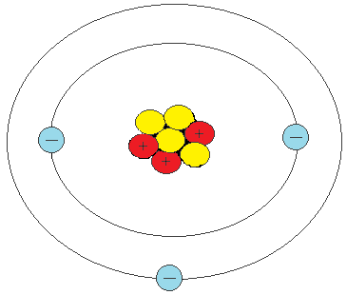

2.

1.

3.

4.

7. Label the following pictures as representing a solid, liquid, or gas.

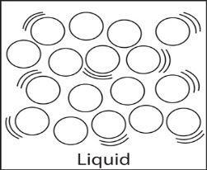

c.

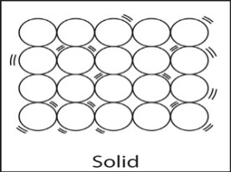

a.

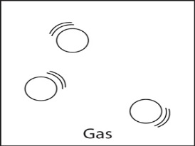

b.

8. What is plasma?

9. The statements below describe solids, liquids, or gases. Rewrite the statements in the correct box in the table below, identifying if they describe solids, liquids, or gases.

-**definite shape, definite volume -matter vibrates in place -molecules moving fast and spread far apart**

|  |  |  |
| --- | --- | --- |
| **Solids** | **Liquids** | **Gases** |
|  |  |  |

**-Indefinite shape, definite volume -matter is least dense -indefinite shape and indefinite volume**

**-matter is most dense -takes shape of container -molecules slide past each other**

**Use the phase change diagram below to answer the questions beside them.**

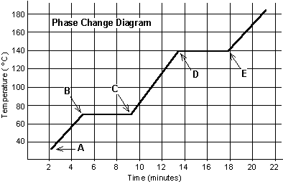

10

a. What is the melting point of the substance? _____°C

b. What is the freezing point of the substance? _____°C

c. What is the boiling point of the substance? _____°C

11.

a. From point A-B, the substance is a ______________.

a. solid b. liquid c. gas

b. From point C-D, the substance is a ______________.

a. solid b. liquid c. gas

c. After point E, the substance is a ________________.

a.solid b. liquid c. gas

12. Complete the following chart and label the

Diagram to the left.

|  |  |  |
| --- | --- | --- |
| **Phase Change** |  | **Endothermic or Exothermic?** |
|  | Solid 🡪 Liquid |  |
|  | Liquid 🡪 Solid |  |
|  | Liquid 🡪 Gas |  |
|  | Gas 🡪 Liquid |  |
|  | Solid 🡪 Gas |  |
|  | Gas 🡪 Solid |  |

18. What is the formula for calculating density? What are the units used to measure density?

|  |  |
| --- | --- |
| **Substance** | **Density** |
| Paraffin | 0.8 g/cm3 |
| Graphite | 0.4 g/cm3 |
| Charcoal | 0.24 g/cm3 |
| Dextrose | 0.5 g/cm3 |

19. You are asked to determine the identity of an unknown substance. You are given a 2 gram sample of the substance that has a volume of 5 cm3. Which of the 4 substances in the table to the right do you have? **SHOW YOUR WORK!**

**Use the chart below to answer the next 2 questions**.

20. If iron pyrite were dropped into a beaker of mercury, would it sink or float? Explain your answer.

21. If iron pyrite were dropped into a beaker of water, would it sink or float? Explain your answer.

|  |  |  |  |
| --- | --- | --- | --- |
| **Substance** | **State** | **Density (g/cm3)** | **Color** |
| Helium | gas | 0.0001663 | colorless |
| Iron pyrite | solid | 5.02 | metallic yellow |
| Mercury | liquid | 13.55 | metallic gray |
| Oxygen | gas | 0.001331 | colorless |
| Water | liquid | 1.00 | colorless |

**For the questions below, calculate the density of each substance described. Then, use the chart to determine the identity of the substance. YOU MAY NEED TO ROUND! SHOW YOUR WORK & UNITS!**

|  |  |
| --- | --- |
| **Substance** | **Density (g/mL)** |
| Air | 0.00129 |
| Gasoline | 0.70 |
| Olive oil | 0.89 |
| Water | 1.0 |
| Ice (0 oC) | 0.92 |
| Aluminum | 2.7 |
| Zinc | 7.0 |
| Iron | 7.8 |
| Nickel | 8.8 |
| Silver | 10.5 |
| Gold | 19.3 |
| Platinum | 21.4 |

22. 49 g of this substance has a volume of 7 cm3.

23. 14 g of this substance has a volume of 14 mL.

24. 107 g of this substance has a volume of 5 cm3.

25. 14 cm3 of this substance has a mass of 147 g.

26. 10 mL of this substance has a mass of 8.9 g.

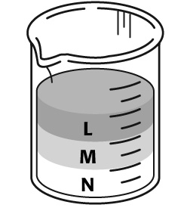

29. Which substance in the beaker to the right has the greatest density? Why?

30. Which substance in the beaker to the right is the least dense? Why?

Jeremy wonders if watering pea plants with salt water will improve their growth. Pea plant clones are given different amounts of salt water for a three-week period.

The first pea plant receives 400 milliliters a day. The second pea plant receives 200 milliliters a day. The third pea plant receives 100 milliliters a day. The fourth pea plant does not receive any extra water; the plant only receives natural ways of receiving water. The height of pea plants is recorded daily.

Identify each of the following:

31. Hypothesis

32. Independent Variable

33. Dependent Variable

34. Constants

35. Control Group

36. Experimental Group

Identify each of the following statements as either an observation (O) or an inference (I):

___ 1. The organism frowned to show it did not like strangers.

___ 2. The organism is green with pink spots.

___ 3. The organism lives near other organisms.

___ 4. The organism moved away from us because it was scared.

___ 5. The organism made gurgling noises.

___ 6. The organism had four spines on its back.

___ 7. The organism has one blue eye and two green eyes.

___ 8. The organism moves really slowly, so he must be old.

**Circle each of the qualitative observations above.**

1.

2.

3.

4.

5.

**For the picture below, list five lab safety infractions.**

