Study Guide- Waves, Sound, and Light
1. Define electromagnetic wave –

2. Give 3 examples of electromagnetic waves.

3. Define mechanical wave –

4. Give 3 examples of mechanical waves.

5. Draw a transverse wave. Label the crest, trough, amplitude, and wavelength.

6. Draw a longitudinal wave. Label a compression and a rarefaction.

7. What is refraction? Define and give an example of light refraction.

8. What is diffraction? Define and give an example of light or sound diffraction.

9. describe the relationship between wavelength and frequency.

10. Rank the order of the speed of sound through the following materials from fastest to slowest.
(Warm air, water, concrete, cold air)
Fastest Slowest

11. Sound is a & wave. (Circle the two that apply) Electromagnetic longitudinal transverse mechanical

12. Describe how frequency and pitch are related.

13. Describe how amplitude and loudness are related.

14. Use the two oscilloscope graphs of sound waves below to answer the questions that follow.
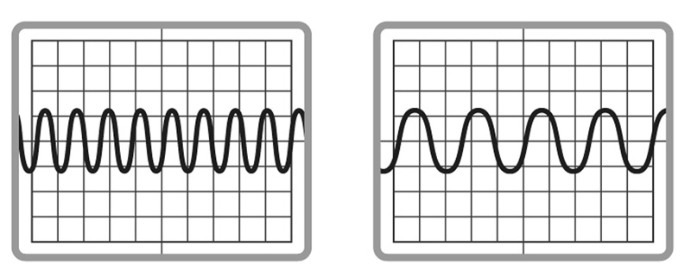

Wave A Wave B
a. Compare the amplitudes of the two waves. Would the volumes of the two sounds be different? Why or why not?

b. Which wave has the highest frequency?

c. Which wave represents the sound with the lowest pitch?

15. Use the oscilloscope graphs of the 4 sounds waves below to answer the questions that follow.
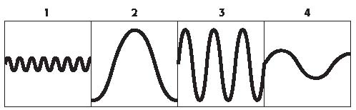

a. Which graph represents the quietest/softest sound? Why?

b. Which 2 sounds are of equal volume, and are the loudest sounds?

c. Which sound has the lowest pitch? Why?

d. Which sound has the highest pitch? Why?

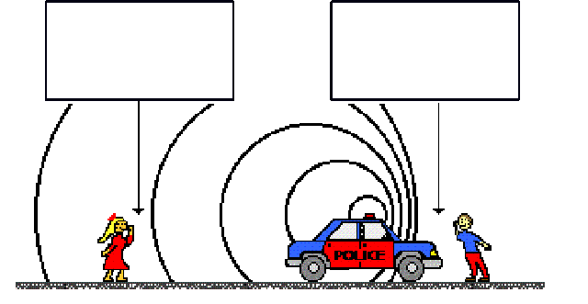
20. Label which side of the police car has high frequency and which side has a low frequency. Then explain what the police siren sounds like to each listener.

21. Rank the order of the speed of light through the following materials from fastest to slowest: air, water, a vacuum (like outer space), glass
Fastest Slowest

22. Light is a & wave. (Circle the two that apply) Electromagnetic longitudinal transverse mechanical

23. Give 1 example of translucent matter.

24. Give 2 examples of transparent matter.

25. Give 3 examples of opaque matter.

26. How does a prism split light into the different colors of the visible spectrum? Explain what light interaction is taking place. Use the words medium and speed in your answer.

27. Put ALL 7 waves on the electromagnetic spectrum in order from LOWEST frequency to HIGHEST frequency. Circle the EM wave that carries the MOST energy. Underline the part of the EM spectrum that human eyes can see/detect. Put a triangle around the wave that carries the LEAST energy.

28. Put ALL colors of the visible spectrum in order from longest wavelength to shortest wavelength.

29. Explain why you see the color orange when you look at an orange. What colors are being reflected? What colors are being absorbed?

30. How do you see the colors white and black? Explain in terms of light reflection and absorption.

31. What happens to light when it hits a mirror? Draw a plane, convex, and concave mirror.

32. How do frequency and energy relate in electromagnetic waves?

33. If a gamma ray and visible light leave the Sun at the same time, which will reach the Earth first? Why?

34. Draw 2 lenses: one concave, and one convex. Which lens is converging? Which is diverging?

35. The color of objects that are opaque depends on the color of light that the objects _____________________.

36. The color of objects that are transparent or translucent depends on the color of light that the objects _____________________.

37. If a sound wave moves through air at 340 m/s and it has a frequency of 256 Hz, what is the wave’s wavelength?

38. If a light wave has a frequency of 1 x 10¹⁵ Hz, and a wavelength of 3 x 10⁻⁷ what is the speed of the light wave?

39. If a wave has a speed of 400 m/s and a wavelength of 200 m, what is the frequency of the wave?

40. If the period of a wave is 25 seconds, what is its frequency and what is it’s the wavelength if it has a speed of 60 m/s?

41. A ship’s sonar sends a signal that bounces off the bottom of the ocean and returns in 8 seconds. If the speed of signal in ocean water is 1,400 m/s, how deep is the ocean at that spot?

