Name Date Class
1. Define work:

2. What unit is used to measure work?

3. What is the formula for calculating work? Work =

4. Define power:

5. What unit is used to measure power?

6. What is the formula for calculating power? Power =

7. Explain why you do work on a bag of groceries when you pick it up but not when you carry it.

8. Jeremy pushes a box that weighs 20 N a distance of 2 m in 5 seconds. Tanya pushes the same box over the same distance, but she completes the task in 8 seconds. Who used the most power? Why? Show your work.

9. You apply a force of 40 N to a box to move it a distance of 3 meters. You do this in 4 seconds.
a. How much work did you do? Show your work below.

b. What was the power output? Show your work below.

10. If a 2 kg ball is accelerated from 2 m/s to 8 m/s over a 12 second period, calculate each of the following:
a. acceleration
b. force
c. distance traveled in 12 seconds
d. work
e. power
11. Define machine: _

11. If a machine changes the size of your input force, it must also change the ______________ through which your force acts.

12. Explain how using a ramp makes work easier. (Hint: explain the force-distance trade off that occurs when you use a machine).

13. Why can’t a machine ever be 100% efficient?

14. Suppose that you exert 60 N on a machine and the machine exerts 300 N on another object. What is the machine’s mechanical advantage? Show your work below.

15. For each machine listed below, give 2 examples of that type of machine.
First class lever
Second class lever
Third class lever
Wedge
Screw
Inclined plane
Pulley
Wheel and axle

16. Define compound machine. _____

17. Give 2 examples of compound machines, then list what simple machines make up those compound machines.

18. What compares the work output and work input of a machine? (efficiency or advantage)

19. What compares force input and force output of a machine? (efficiency or advantage)

20. What formula is used to calculate mechanical efficiency? Write the formula below.

21. What formula is used to calculate mechanical advantage? Write the formula below.

22. A machine makes work easier by changing at least one of three factors. What are the three factors that a machine can change?

23. Label the levers below as representing first, second, or third class levers.
A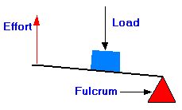 B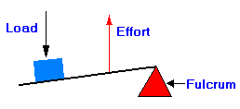 C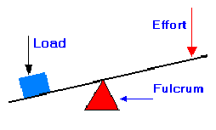

24. Use the information in the chart below to calculate the mechanical advantage of each machine.
Pulley | Force Input | Force Output | Mechanical Advantage
A | 20 N | 40 N
B | 3 N | 30 N
C | 10 N | 10 N
D | 5 N | 30 N
25. Which pulley would make your work the easiest?

26. Use the information in the chart below to calculate the mechanical efficiency of each machine.
Lever | Work Input | Work Output | Mechanical Efficiency
A | 40 J | 5 J
B | 40 J | 10 J
C | 24 J | 8 J
D | 15 J | 20 J

27. Which lever would NOT be possible? Why?

Use the boxes above to map the vocabulary listed in the concept map. Place the correct term in the appropriate box.
Actual Mechanical advantage Compound Machines
First Class Lever Fixed Pulley
Friction Ideal Mechanical Advantage
Inclined Planes Inclined Plane
Levers Lever
Machines Mechanical Advantage
Moveable Pulley Pulley
Screw Second Class Lever
Simple Machines Third Class Lever
Wedge Wheel and Axle

